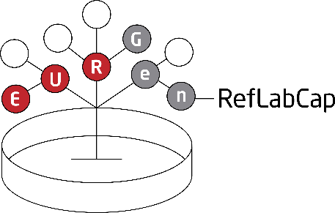

EURGen-RefLabCap

Technical training workshop #1
29 November 2022 and 7-8 December 2022

Virtual and physical technical training workshop on WGS and
bioinformatics analysis applied to CCRE

This is the first of two physical training workshops to be held during the EURGen-RefLabCap project period. The workshops will focus on hands-on training for whole-genome sequencing (WGS) and bioinformatics analysis of relevant pathogens, with the aim of building capacity for national detection and surveillance of antimicrobial resistance, and other reference laboratory functions, covered under the project.
The first workshop focuses on short-read sequencing technologies applied to analysis of carbapenem and colistin resistant Enterobacterales (CCRE), including laboratory training on Illumina sequencing and exercises with bioinformatics tools.

The first day of the workshop will be held virtually on 29 November 2022.
The following two days of the workshop will be held physically at the Technical University of Denmark (DTU) on 7 and 8 December 2022.

Agenda:
First day (virtual) – Tuesday 29 November 2022, 10:00 - 12:30 CET
10:00 - 10:15: Introduction and agenda for the day (Ana Rita Rebelo, DTU)
10:15 - 11:00: From isolate to WGS - biochemical principles (Ana Rita Rebelo, DTU)
11:00 - 11:15: Coffee break
11:15 - 12:00: From isolate to WGS - WGS data and bioinformatics (Jette Sejer Kjeldgaard, DTU)
12:00 - 12:30: Quality control of WGS data (Ana Rita Rebelo, DTU)
Second day (physical) – Wednesday 7 December 2022, 9:00 - 17:00 CET
[8:15: Bus transportation provided from the hotel to DTU]
9:00 - 9:30: Introduction and agenda for the day (Ana Rita Rebelo, DTU)
9:30 - 15:00: Laboratory work - Illumina MiSeq library preparation and sequencing (including ad hoc coffee and lunch)
15:00 - 15:30: Coffee break
15:30 - 16:15: Exercise about quality control of WGS data (Ana Rita Rebelo, DTU)
16:15 - 17:00: Exercise about bioinformatics tools for species identification and subtyping (Jette Sejer Kjeldgaard, DTU)
[17:00: Bus transportation provided from DTU to the restaurant]

17:45 : Project dinner at Restaurant Bistro Royal København (Kongens Nytorv 26, 1050 København K)

Third day (physical) – Thursday 8 December 2022, 9:00 - 15:30 CET
[8:15: Bus transportation provided from the hotel to DTU]
9:00 - 9:15: Re-cap and agenda for the day (Jette Sejer Kjeldgaard, DTU)
9:15 - 10:00: Discussion and conclusions of exercise about species identification and subtyping tools (Jette Sejer Kjeldgaard, DTU)
10:00 - 11:00: Exercise about bioinformatics tools for detection of antimicrobial resistance and mobile genetic elements (Markus Johansson, DTU)
11:00 - 11:15: Coffee break
11:15 - 12:00: Discussion and conclusions of exercise about antimicrobial resistance and mobile genetic elements (Markus Johansson, DTU)
12:00 - 12:30: Cluster methods (SNP-based and gene-by-gene) and tools, and the importance of metadata (Ana Rita Rebelo, DTU)
12:30 - 13:30: Lunch break
13:30 - 15:00: Exercise about cluster analysis (Ana Rita Rebelo and Jette Sejer Kjeldgaard, DTU)
15:00 - 15:30: Discussions, wrap-up, goodbye
[15:30: Bus transportation provided from DTU to the hotel]

